GSD High School Supply List



High School

* 1 backpack
* 3 packs of notebook paper (wide or college ruled)
* 4 packs of pencils (regular/ mechanical lead)
* 1 pack of blue or black pens
* 2 packs of colored pencils
* 3 multi-colored highlighters
* 3 packs of loose-leaf paper (wide or college ruled)
* 5 composition notebooks

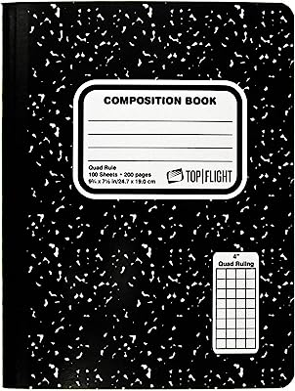

**Wish List**

* Kleenex
* Hand sanitizer
* Antibacterial wipes